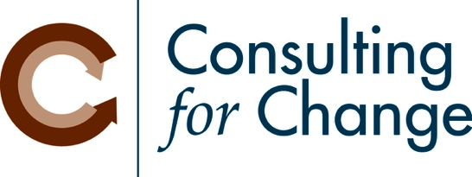

Skills and Abilities needed at a CDFI

Skill | Your Staff  1 = weak, 5 = strong | Thoughts, Comments
Writing for grants / grant reports | 1 2 3 4 5
Researching grant opportunities | 1 2 3 4 5
Cultivating funder relationships | 1 2 3 4 5
Monitoring performance for funders and investors | 1 2 3 4 5
Marketing your products and services to the target market | 1 2 3 4 5
Social media | 1 2 3 4 5
Assisting applicants to apply | 1 2 3 4 5
Capacity building for applicants | 1 2 3 4 5
Analyzing loan applications (non-financial) | 1 2 3 4 5
Financial analysis of applicants | 1 2 3 4 5
Closing loans | 1 2 3 4 5
Invoicing for loans | 1 2 3 4 5
Applying payments | 1 2 3 4 5
Monitoring other loan requirements (insurance, impact, etc.) | 1 2 3 4 5
Working with borrowers who are behind in payments | 1 2 3 4 5
Collections | 1 2 3 4 5
Promoting the CDFI to your Tribe / local government | 1 2 3 4 5
Getting positive media attention | 1 2 3 4 5
Bookkeeping | 1 2 3 4 5
Preparing financial statements | 1 2 3 4 5
Preparing financial projections | 1 2 3 4 5
Organizing materials for the Board | 1 2 3 4 5
Running effective Board meetings | 1 2 3 4 5
Other:

