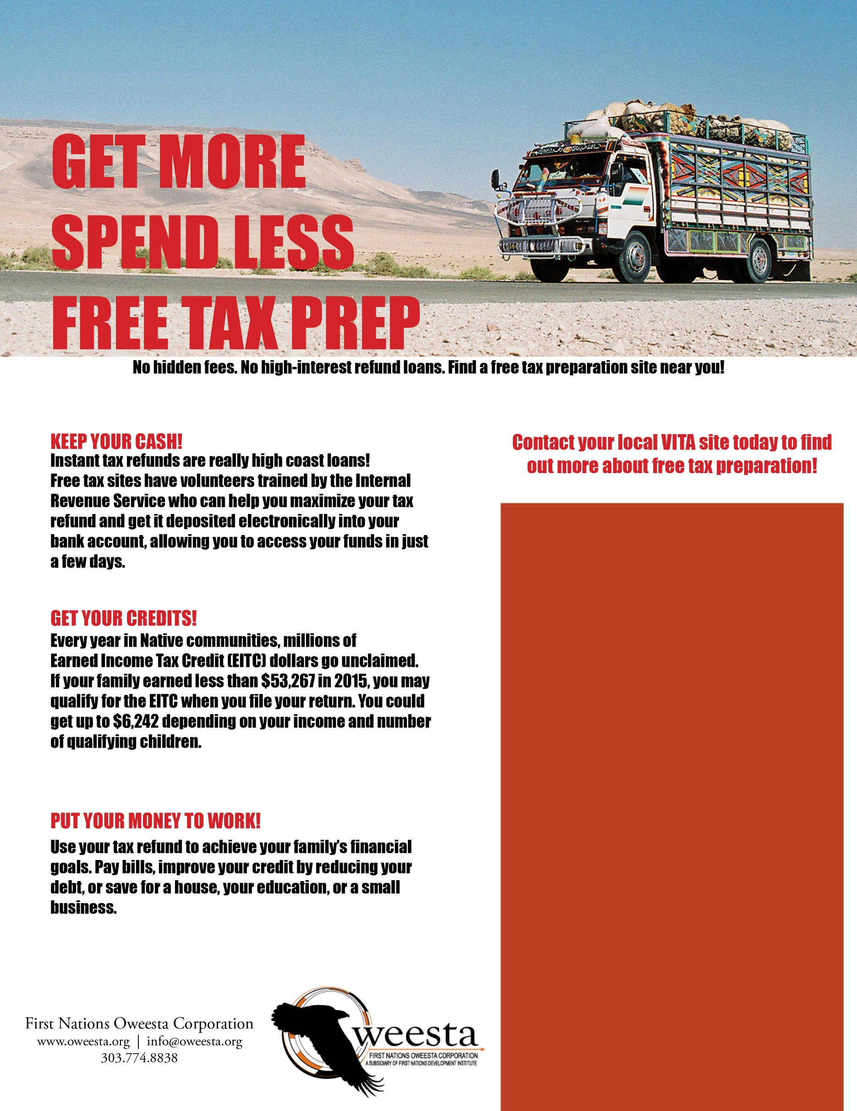

Insert location and hours of nearest free tax prep site and name and logo of your organization here.

Insert location and hours of nearest free tax prep site and name and logo of your organization here.

Insert location and hours of nearest free tax prep site and name and logo of your organization here.